- The long-awaited UK Budget featured a small near-term loosening of fiscal policy and a larger longer-term tightening. The initial market reaction was positive, but we think markets will gradually lose faith, and the risk of a sudden confidence crisis remains live.
- Markets were reassured by the Chancellor building in greater headroom and the Debt Management Office skewing towards shorter issuance. But the backloaded nature of the measures, the uncertain impact of many of the tax-raising measures, a lack of spending restraint, and the absence of growth measures undermined the credibility of the package.
After a seemingly endless buildup, Budget Day finally arrived this week. On the face of it, the Chancellor largely achieved her aims, keeping both markets and members of her party onside. But we think it might turn out to be one of those Budgets that sours over time.
As expected, the Office for Budget Responsibility downgraded its productivity forecast. But the impact on its borrowing projections was mitigated by favourable revisions elsewhere that meant the repair job was much smaller than anticipated. This gave the Chancellor greater flexibility, and she opted to implement a modest near-term loosening of policy, followed by a larger tightening later (Chart 1). The belated tightening was designed to increase her headroom to a level that would reduce the risk of repeating the kind of policy uncertainty that we’ve seen since the government came to power.
Chart 1: The Budget presented a near-term spending increase and a backloaded package of tax rises
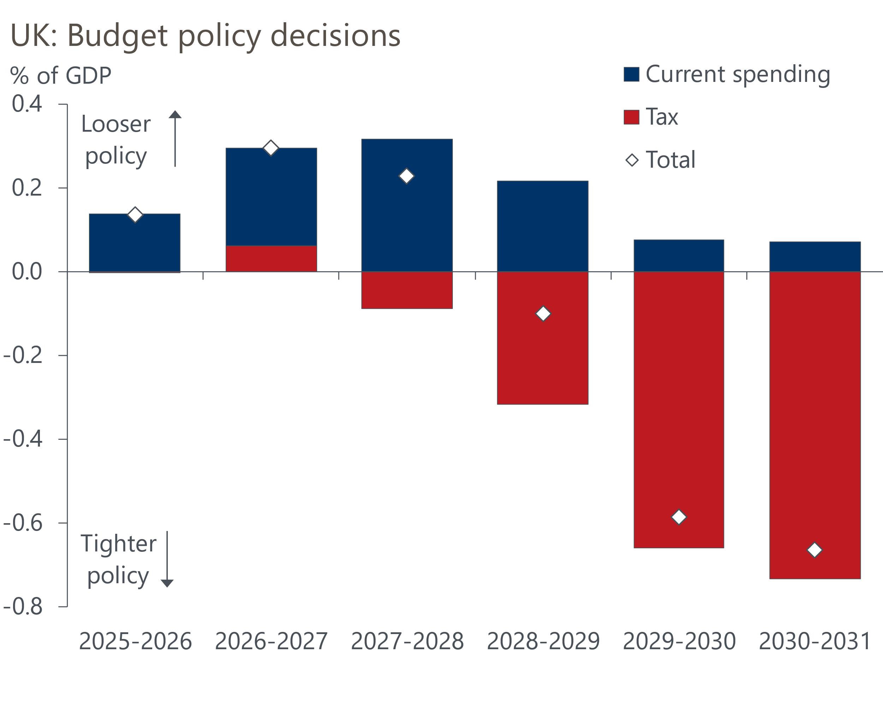
Sources: HM Treasury
The greater headroom and the Debt Management Office skewing towards shorter issuance appeared to reassure markets. At market close on Thursday, the 10-year gilt yield was around 10bps down on its level at the start of the week, while sterling was slightly stronger. But we doubt this will last, for several reasons.
The first of those is the backloaded nature of the tightening. This isn't just a problem in terms of risking consolidation fatigue. The new plans imply a £17bn (0.5% of GDP) tightening in fiscal year 2029-2030, a year when the next general election is due to take place (Chart 2). By then the target year for the fiscal rules will be moving out again, and we think it very unlikely this tightening will be fully implemented.

Chart 2: We find it hard to believe the government will tighten fiscal policy in an election year
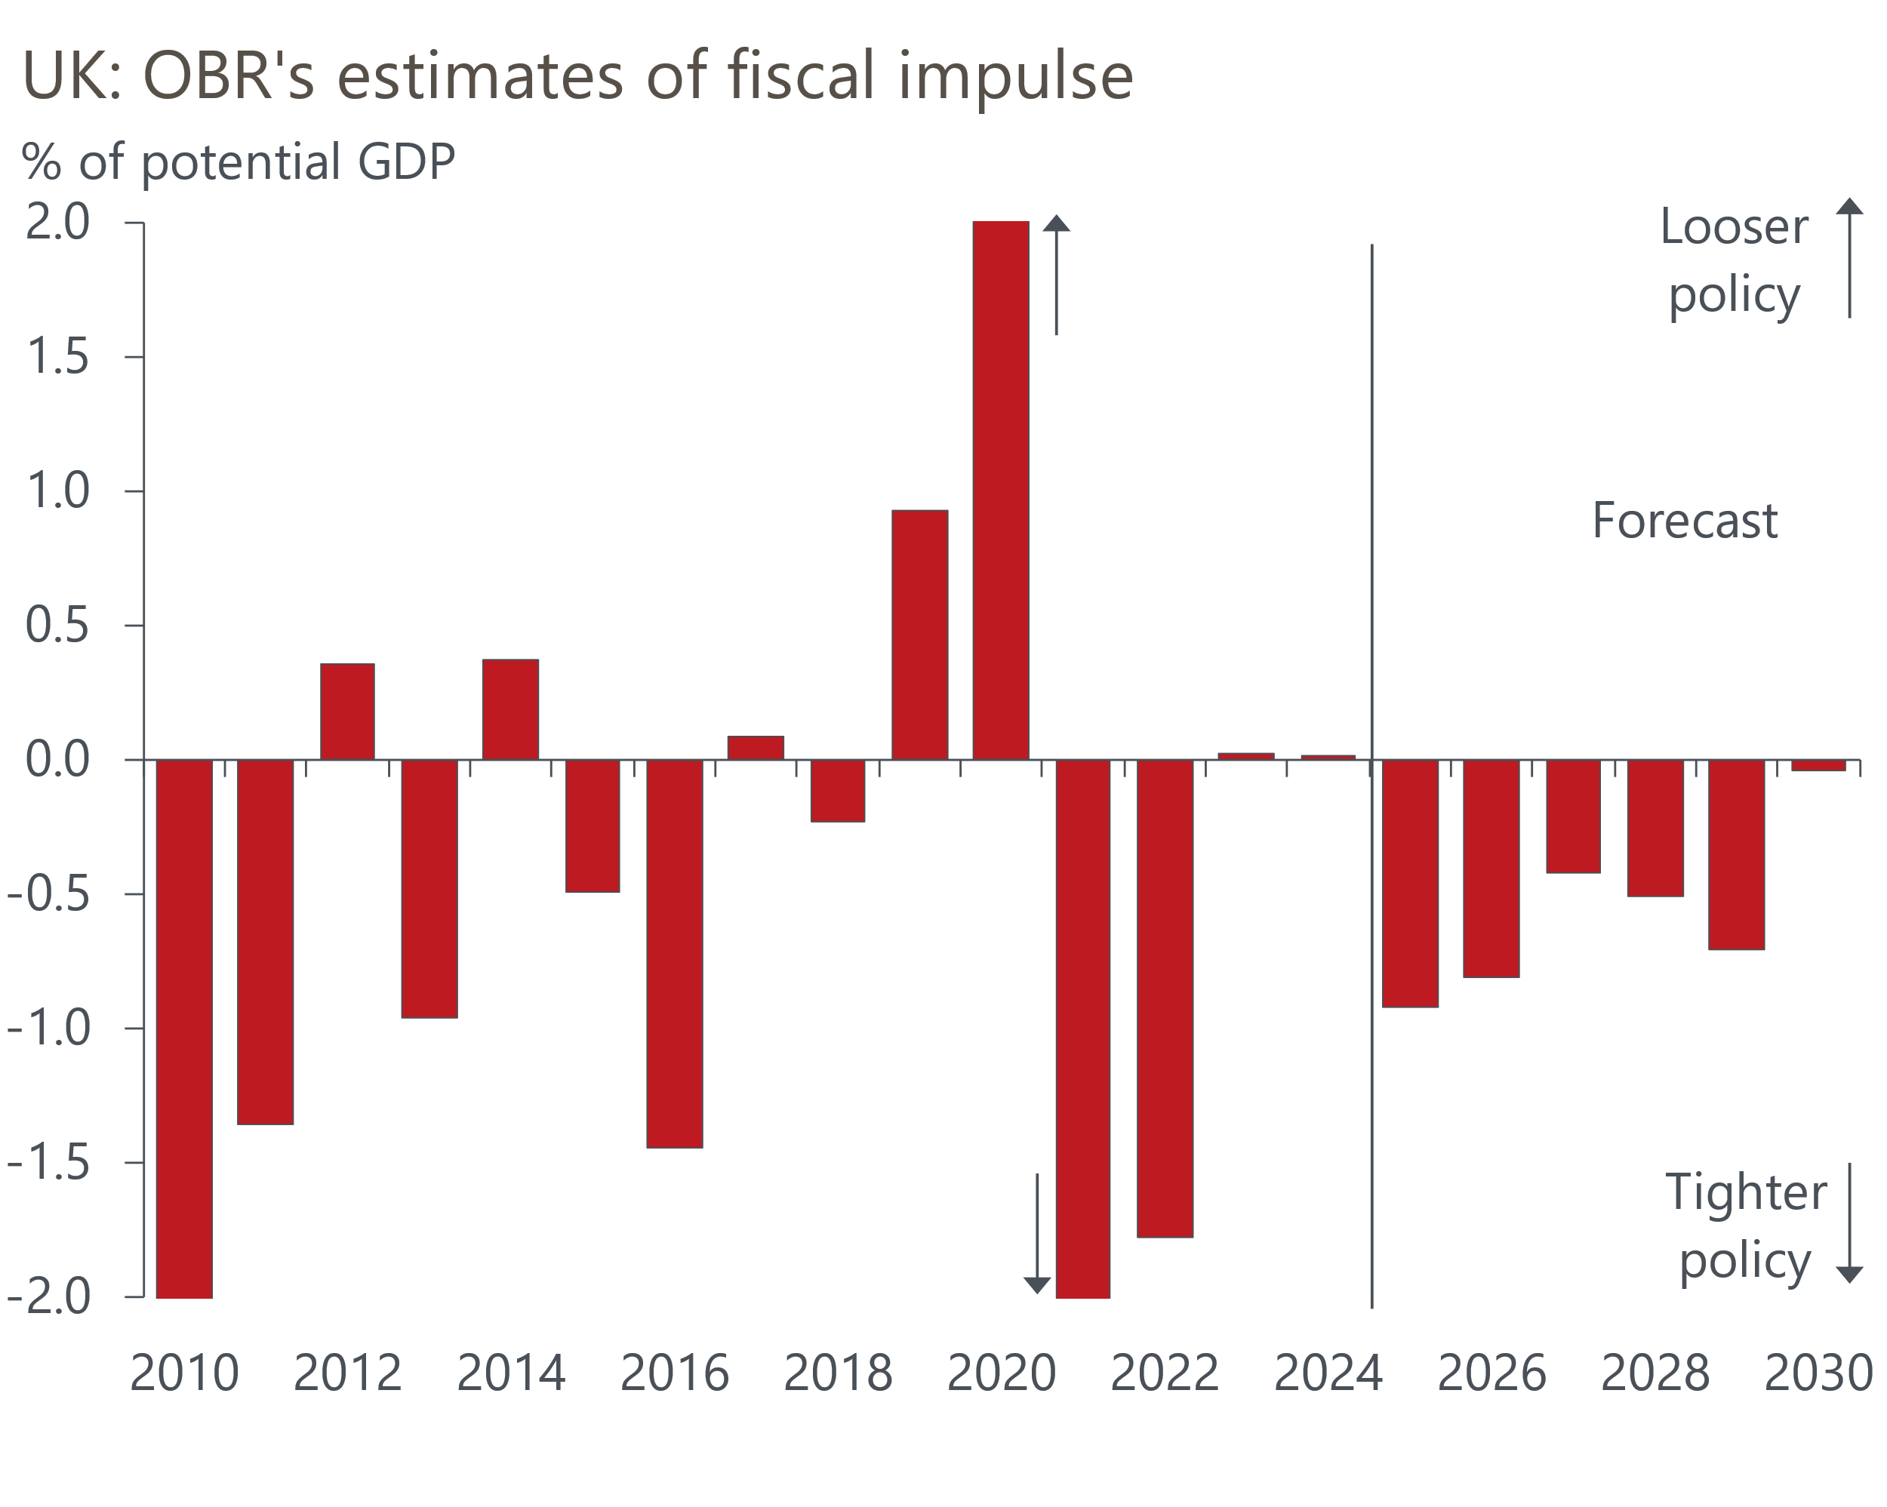
Source: Oxford Economics calculations using data from Office for Budget Responsibility
Second, the Chancellor made no attempt to restrain spending, apart from the inclusion of some unspecified "efficiency savings" in the last two years of the forecast. Indeed, the OBR forecasts show the spending-to-GDP ratio higher at end of the forecast period than it was last year, placing all the burden on tax hikes. History suggests that revenue-based consolidations have a higher risk of failure. The Chancellor's decision also risks adding to the perception that the government lacks the internal discipline to cut spending.
Third, apart from the extension of the threshold freeze, the tax measures encompassed a wide variety of large increases to smaller revenue streams. Such changes often trigger behavioural change, so revenue projections are more speculative. And as the experience of the October 2024 Budget demonstrates, they tend to result in specific groups being hit particularly hard, which can sometimes make the measures politically unsustainable.
Finally, there were no major measures to boost growth. The OBR revised down its growth forecasts, which were previously more optimistic than any independent forecaster, but they still look too high in our view. Its new projection is in line with the strongest forecast of the consensus. But with this week's new population data reporting much lower net inward migration than is assumed in the OBR's forecast, there's already questions over whether its projections will prove achievable.
We think that confidence will dwindle as markets question the credibility of the package. This will likely result in a slow burn of rising risk premia and a falling pound. That could morph into a more sudden loss of confidence, given a set of unfavourable surprises, so the downside scenario that we outlined last month remains a live risk.
We will incorporate the Budget policy measures and the new population data into our next forecast update on December 8. Our near-term growth forecast is likely to be little changed, reflecting the modest nature of the near-term loosening. Our medium-term forecast will likely be slightly lower, reflecting the impact of weaker population growth. But this week's population update from the Office for National Statistics was very light on detail, and we will have to wait for the full dataset to become available before we can make a more considered judgment on the implications for the medium-term growth outlook.
Our inflation forecast will likely be slightly lower next year, reflecting the impact of changes to energy bills announced by the Chancellor. This will be mitigated by the first baby steps towards increasing fuel duty for the first time since 2011. Still, we're sceptical the government will fully follow through with its plans to raise fuel duty at quarterly intervals between September 2026 and March 2027.
We don’t think the Budget materially changes the outlook for monetary policy. The Monetary Policy Committee is likely to cut rates again at one of the next two meetings – we continue to slightly favour December.

The week ahead
Now that the stamp duty distortions have faded, it's clear that the housing market is in decent health. Mortgage approvals were at a nine-month high in September, reflecting the gradual decline in quoted mortgage rates through over the past year. We expect approvals to come in at 65,900 in October, consolidating the big gain made in the previous month.
Net secured lending has been strengthening in response to the pickup in approvals in the summer. After September's big increase, we expect gross lending to be slightly lower in October. But net lending of £5.1bn would still be almost double the average of the past couple of years.
Consumer credit edged down in September, as gross lending dropped back. We forecast that net unsecured lending held steady at £1.5bn in October.
Next week also sees the final S&P Global surveys for November. The flash results were soft, likely reflecting the damage to sentiment from rumours of large tax rises in this week's Budget. There's been some substantial revisions between the flash and final results of late, though there doesn't seem to be a systematic pattern to the revisions.
Table 1: Week ahead calendar
Date | Events | Period | Measure | Unit | Previous | Forecast
Dec 1 | Mortgage approvals | Oct | Level | 000s | 65.9 | 65.9
Dec 1 | Mortgage lending | Oct | Net lending | £bn | 5.5 | 5.1
Dec 1 | Consumer credit | Oct | Net lending | £bn | 1.5 | 1.5
Dec 1 | S&P Global manufacturing | Nov | PMI | % bal | 50.2 | 50.2
Dec 3 | S&P Global services | Nov | PMI | % bal | 50.5 | 50.5
Dec 3 | S&P Global composite | Nov | PMI | % bal | 50.5 | 50.5
Dec 4 | S&P Global construction | Nov | PMI | % bal | 44.1 | 43.0
Source: Oxford Economics

Key forecasts
Table 2: UK forecast overview
(Annual percentage changes unless specified)
 | 2023 | 2024 | 2025 | 2026 | 2027 | 2028
GDP | 0.3 | 1.1 | 1.4 | 0.9 | 1.3 | 1.6
Private consumption | -0.3 | -0.2 | 0.9 | 1.0 | 1.1 | 1.5
Fixed investment | 0.5 | 1.8 | 2.8 | -0.1 | 1.5 | 2.0
Government consumption | 2.1 | 3.4 | 2.0 | 1.6 | 1.6 | 1.7
Exports of goods and services | -2.3 | 0.6 | 2.8 | -0.2 | 1.2 | 1.5
Imports of goods and services | -1.6 | 2.6 | 3.5 | -0.7 | 1.2 | 1.5
Industrial production | -2.6 | -1.6 | -0.5 | -0.1 | 1.1 | 1.3
Consumer prices | 7.3 | 2.5 | 3.4 | 2.8 | 2.5 | 2.2
Unemployment rate (%) | 4.1 | 4.3 | 4.8 | 5.1 | 5.0 | 4.6
Current a/c balance (% of GDP) | -3.6 | -2.2 | -3.0 | -2.6 | -2.4 | -2.3
Government balance (% of GDP) | 5.2 | 5.2 | 4.8 | 3.4 | 3.1 | 2.7
Central bank policy rate (%, EOP) | 5.25 | 4.75 | 3.75 | 3.25 | 3.00 | 2.75
10yr govt. bond yield (%, EOP) | 3.54 | 4.57 | 4.60 | 4.24 | 3.76 | 3.48
Exchange rate (US$ per £, EOP) | 1.27 | 1.25 | 1.29 | 1.29 | 1.29 | 1.29
Exchange rate (euro per £, EOP) | 1.15 | 1.21 | 1.11 | 1.11 | 1.11 | 1.11
Source: Oxford Economics
Table 3: Quarterly forecasts for the UK
 | 2025 |  |  |  | 2026
 | Q1 | Q2 | Q3 | Q4 | Q1 | Q2 | Q3 | Q4
GDP (% year) | 1.8 | 1.4 | 1.3 | 1.2 | 0.8 | 0.8 | 1.0 | 1.0
CPI inflation (% year) | 2.8 | 3.5 | 3.8 | 3.6 | 3.3 | 2.5 | 2.7 | 2.6
Bank Rate (%, EOP) | 4.50 | 4.25 | 4.00 | 3.75 | 3.75 | 3.50 | 3.50 | 3.25
10yr gilt yield (%, EOP) | 4.70 | 4.48 | 4.70 | 4.60 | 4.57 | 4.49 | 4.38 | 4.24
US$ per £ (EOP) | 1.29 | 1.37 | 1.35 | 1.29 | 1.29 | 1.29 | 1.29 | 1.29
Euro per £ (EOP) | 1.20 | 1.17 | 1.15 | 1.11 | 1.11 | 1.11 | 1.11 | 1.11
Source: Oxford Economics

Latest Country Economic Forecast:
November 18, 2025

Recent publications

Data Insights
Pre-Budget concerns weigh on the PMI
October's drop in retail sales shouldn't be a source of concern
Precarious public finances make for a difficult Budget
October's softer inflation print keeps December rate cut on track
GDP fell in September, as industrial production slumped

Research Briefings
Budget papers over the cracks but can't hide the fiscal risks
Better affordability puts housing market on firmer footing
Dovish hold in November puts a December rate cut in play
MPC preview – softer data unlikely to herald November cut
What should the Chancellor do in the Budget?

Contacts

Oxford Economics' UK team
- Andrew Goodwin - Chief UK Economist - agoodwin@oxfordeconomics.com
- Edward Allenby - Senior UK Economist - eallenby@oxfordeconomics.com

